**MICROCONTROLLER AND MICROPROCESSOR**

**I. Repeat the following words and word combinations after the speaker, paying attention to their pronunciation (2 phases):**

|  |  |
| --- | --- |
| 1. integrated circuit (IC) | интегральная схема (ИС) |
| 2. to implement certain tasks | выполнять определенные задачи |
| 3. automatically controlled | с автоматическим управлением |
| 4. power tools | средства с большими техническими возможностями |
| 5. automobile engine control system | система управления двигателем автомобиля |
| 6. imbedded | встроенный |
| 7. the Central Processing Unit (CPU) | центральный процессор (ЦП) |
| 8. Random-Access Memory (RAM) | запоминающее устройство с произвольной выборкой (ЗУПВ) |
| 10. the Flash Memory | флеш-память, «флешка» |
| 11. the Serial Bus Interface | интерфейс последовательной шины |
| 12. the Electrical Erasable Programmable Read-Only Memory (EEPROM) | электрически стираемое программируемое постоянное запоминающее устройство (ЭСППЗУ), произносится “double-E PROM” |
| 13. SoC (system-on-a-chip) | система на кристалле, однокристальная система |
| 14. arithmetical and logical unit (ALU) | арифметико-логическое устройство (АЛУ) |
| 15. control unit | устройство управления, управляющее устройство |
| 16. register array | матрица регистров |
| 17. to store data in memory | хранить информацию в памяти |
| 18. to process data | обрабатывать данные |

II. Read the sentences with the new words after the speaker, imitating the speaker's pronunciation (2 phases):

1. A microcontroller is a single Integrated Circuit (IC) that is typically used for a specific application and designed to implement certain tasks**.**
2. Microcontrollers are built into products and devices that must be automatically controlled in certain situations, like appliances, power tools, automobile engine control systems.
3. A microcontroller gathers input, processes this information, and outputs a certain action based on the information gathered.
4. Microcontrollers usually operate at lower speeds because they are embeddedinside other devices that can have greater power consumptions in other areas.
5. The essential components inside of microcontroller are the following: the Central Processing Unit (CPU), the Random-Access Memory (RAM), the Flash Memory, the Serial Bus Interface, the Input/Output Ports (I/O Ports), and in many cases, the Electrical Erasable Programmable Read-Only Memory (EEPROM).
6. All of these components are much reduced in scope/capacity on a microcontroller than a comparable SoC in a personal computer.
7. The microprocessor is the central unit of a computer system that performs arithmetic and logic operations, which generally include adding, subtracting, transferring numbers from one area to another, and comparing two numbers.
8. A microprocessor accepts binary data as input, processes that data, and then provides output based on the instructions stored in the memory.
9. The data is processed using the microprocessor's ALU (arithmetical and logical unit), control unit, and a register array.
10. The flow of instructions and data through the system is managed by the control unit.

**III.** **Translate these sentences into Russian using a dictionary. Put down the translation into your notebook.**

**IV.** **Read the following text sentence by the sentence after the speaker, paying attention to the correct pronunciation (2 phases):**

**Microcontroller and Microprocessor**

With IoT (Internet of things) rapidly increasing and data constantly being gathered, microcontrollers are a huge part of the modern world.

A microcontroller (sometimes called an MCU or Microcontroller Unit) is a single Integrated Circuit (IC) that is typically used for a specific application and designed to implement certain tasks, they are built into products and devices that must be automatically controlled in certain situations, like appliances, power tools, automobile engine control systems.

Essentially, a microcontroller gathers input, processes this information, and outputs a certain action based on the information gathered. Microcontrollers usually operate at lower speeds, around the 1MHz to 200 MHz range, and need to be designed to consume less power because they are embedded inside other devices that can have greater power consumptions in other areas.

A microcontroller can be seen as a small computer, and this is because of the essential components inside of it; the Central Processing Unit (CPU), the Random-Access Memory (RAM), the Flash Memory, the Serial Bus Interface, the Input/Output Ports (I/O Ports), and in many cases, the Electrical Erasable Programmable Read-Only Memory (EEPROM).

All of these components, however, are much reduced in scope/capacity on a microcontroller than a comparable SoC in a personal computer. A MCU would commonly be found controlling basic behaviours in, say, a hairdryer or a calculator, but would offer pointlessly limited function in a more complex machine such as a full computer.

The microprocessor is the central unit of a computer system that performs arithmetic and logic operations, which generally include adding, subtracting, transferring numbers from one area to another, and comparing two numbers. It's often known simply as a processor, a central processing unit, or as a logic chip. It's a programmable, multipurpose device that incorporates the functions of a CPU (central processing unit) on a single IC (integrated circuit).

A microprocessor accepts binary data as input, processes that data, and then provides output based on the instructions stored in the memory. The data is processed using the microprocessor's ALU (arithmetical and logical unit), control unit, and a register array. The register array processes the data via a number of registers that act as temporary fast access memory locations. The flow of instructions and data through the system is managed by the control unit.

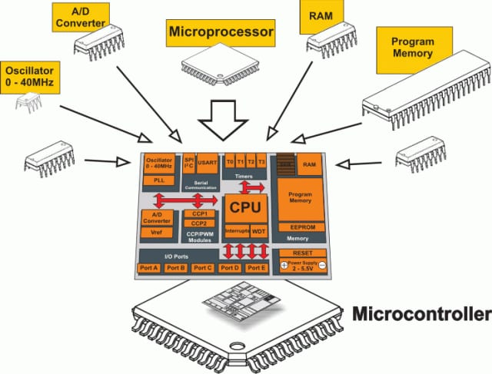

**V. Read the sentences from the text that can be answers to the following questions (4 phases):**

1. What is a microcontroller? How is it called?
2. What is a microcontroller used for?
3. What types of devices are the microcontrollers built into?
4. Why do they operate at lower speeds?
5. What are the essential components of a microcontroller?
6. What is a microprocessor? What operations does it perform?
7. What functions does a microprocessor incorporate?
8. How does it work? How is the data processed?

**VI. Be ready to speak about a microcontroller and a microprocessor using the questions from exercise V as a plan.**

**If you failed to tell about it, do the laboratory work once more, please.**

**The laboratory work is over.**

Thank you for your work.